Unit 3 Questions – All Topics - No Order
- ﻿How does the automatic adjustment mechanism move the economy to potential real gross domestic product (GDP) in the long run when current real GDP is above potential GDP
- Nominal wages falling the short run supply curve to the right
- Nominal wages fall shifting the short run aggregate supply curve to the left
- Nominal wages do not change, shifting the short-nun aggregate supply curve to the right
- Nominal wages rise, shifting the short-run aggregate supply curve to the right
- Nominal wages rise shifting the short aggregate supply curve to the left
- Assume that the marginal propensity to consume is 0.8. If the government increases its purchases of goods and services by $200 and exports decline by $50, at most the equilibrium level of income will
- decrease by $250
- decrease by $1,000
- increase by $150
- increase by $750
- increase by $1,250
- Assume that a country's economy is in a short-run equilibrium and the actual unemployment a lower than the natural rate of unemployment
- Using a correctly labeled graph of the long-run aggregate supply curve, short-run aggregate supply curve, and aggregate demand curve, show each of the following
- Current price level labeled PL, and current output levelled
- The full employment output level labeled Y
b. What open-market operation can the country's central bank use to move the economy towards long run equilibrium?
c. Use a correctly labeled moneymaker graph to show how the country's central bank action to move the economy toward its long run equilibrium affects the equilibrium nominal interest rate in the short run.
d. Based on the interest rate change from part (c) will each of the following increase, decrease, or remain the same in the short run?
- Real Output. Explain
- Natural rate of unemployment
e. Assumed that the central bank does not pursue the monetary policy action from part() and there was no other government intervention. Will each of the following increase, decrease, or remain the same in the long run?
- SRAS. Explain.
- Employment
- Assume that the marginal propensity to come 90. As a result of an increase in the tax rates, the government collects an additional $20 million. What will be the impact on gross domestic product (GDP)
- GDP increase by a maximum of $200million
- GDP increase by a maximum of $180 million
- GDP will decrease by a maximum of $200 million
- GDP will decrease by a maximum of 180 million
- GDP will decrease by a maximum of $20 million
- ﻿The aggregate demand curve assumes that
- as the price of a good or service increases, nominal wages decrease
- as the domestic price level increases, consumers substitute domestic goods for foreign goods
- all prices and total consumer incomes are constant
- changes in the price level affect real wealth
- nominal interest rates increase as the price level decreases
- In the long run, if AD decreases, RGDP and the price level change in which of the following ways?
RGDP Price Level
- Decrease Decrease
- Decrease Increase
- No change Decrease
- Increase Decrease
- No change Increase
- If a change in aggregate demand results in a recession, the price level and real output will change in which of the following ways in the short run?
Price Level Real Output
- No change Increase
- Increase No change
- Increase Decrease
- Decrease No change
- Decrease Decrease
- Aggregate demand may be measured by adding
- consumption, investment, savings, and imports
- savings, government spending, and business inventories
- consumption, investment, government spending, and net exports
- domestic private expenditures and government spending
- domestic expenditures and imports﻿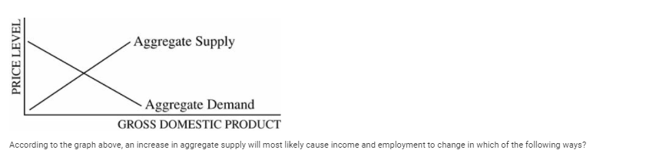
- According to the graph above, an increase in AS will have what effect?
Income Employment
- Decrease Decrease
- Decrease Increase
- No change Increase
- Increase Decrease
- Increase Increase
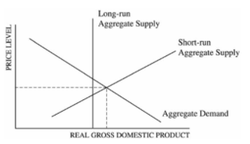
- According to the graph above, which of the following is true about the long-run equilibrium of the economy depicted?
- The economy is in long-run equilibrium.
- The aggregate demand curve will shift to the left to restore long-run equilibrium.
- The long run aggregate supply curve will shift to the right to restore long-run equilibrium.
- Without a fiscal policy stimulus, the economy will remain in a recession.
- As wages increase, the short-run aggregate supply curve will shift to the left to restore long-run equilibrium.
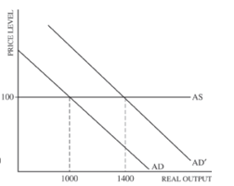
- The graph above shows the aggregate supply (45) and aggregate demand (AD) curves for an economy
- Calculate the spending multiplier if AD shifts to AD/ as a result of an increase in Government spending of $100
- Will decrease in income taxes have to be large male or equal to $100 in order to the AD by the same amount as the $100 increase in spending? Explain
- If the MPS to decreases, will the spending multiplier increase, decrease or stay the same?
- Now assume the AS is upward sloping. Would the change in real gross domestic product resulting from the $100 increase in government spending be greater, less or equal to the change shown in the graph?
- Now assume wages are prices are perfectly flexible. As a result of the $100 increase, will RGDP increase, decrease or remain unchanged?
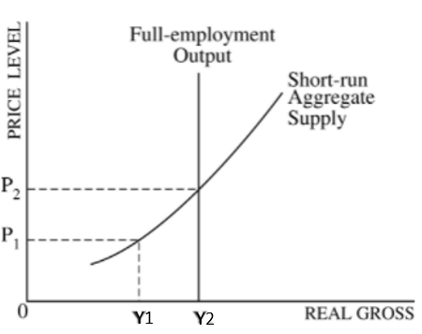
- The graph shows the macroeconomic conditions of Wattsonia. Many economists estimate the NRU is 6 percent. If this is true and the current rate of unemployment is 5.1 percent, in what range of RGDP is the economy currently producing?
- Less than Y1
- At Y1
- At Y2
- Greater than Y1 and less than Y2
- Greater than Y2
﻿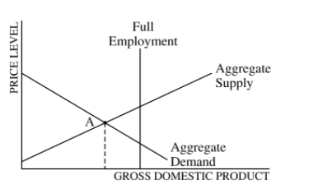
- The economy of a country is currently in equilibrium at point A in the diagram above. If the government does nothing and wages are flexible, which of the following will most likely occur in the long run?
- Falling wages will shift the aggregate demand curve to the right, producing full employment.
- Rising wages will shift the aggregate demand curve to the right, producing full employment.
- The economy will remain at point A
- Rising wages will shift the aggregate supply curve to the right, producing full employment.
- Falling wages will shift the aggregate supply curve to the right, producing full employment.
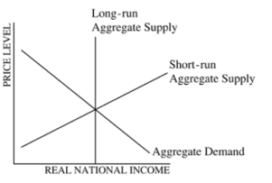
- Assume that the economy is at full-employment equilibrium in the diagram shown above. Which of the following would lead to station?
- A leftward shift of the short-run aggregate supply curve only
- A rightward shift of the short-run aggregate supply curve only
- A leftward shift of the aggregate demand curve only
- A rightward shift of the aggregate demand curve only
- A rightward shift in both the short-run aggregate supply curve and the aggregate demand curve
- Stagflation will be caused by a
- Leftward shift of SRAS
- Rightward shift of SRAS
- Leftward shift of AD
- Rightward shift of AD
- Rightward shift of both AD and SRAS
- In answering the question, you should emphasize the line of reasoning that generated your results; it is not enough to list the results of your analysis. Include correctly labeled diagrams, if useful or required, in explaining your answer. A correctly labeled diagram must have all axes and curves clearly labeled and must show directional changes. Assume the economy of Andersonland is in a long-run equilibrium with full employment. In the short run, nominal wages are fixed.
a. Draw a correctly labeled graph of short-run aggregate supply, long-run aggregate supply, and aggregate demand. Show each of the following.
- Equilibrium output, labeled Y1
- Equilibrium price level, labeled PL1
b. Assume that there is an increase in exports from Andersonland. On your graph in part (a), show the effect of higher exports on the equilibrium in the short run, labeling the new equilibrium output and price level Y2 and PL2, respectively.
c. Based on your answer in part (b), what is the impact of higher exports on real wages in the short run? Explain.
d. As a result of the increase in exports, export-oriented industries in Anderson and increase expenditures on new container ships and equipment.
- What component of aggregate demand will change?
- What is the impact on the long-run aggregate supply? Explain.
- An aggregate supply curve may be horizontal over some range because within that range
- a higher price level leads to higher interest rates, which reduce the money supply and consumer spending
- changes in the aggregate price level do not induce substitution
- output cannot be increased unless prices and interest rates increase
- rigid prices prevent employment from fluctuating
- resources are underemployed and an increase in demand will be satisfied without any pressure on the price level
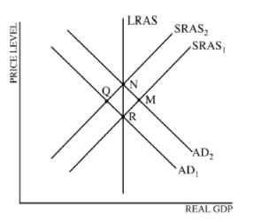
- According to the graph above and starting with equilibrium point R, which of the following shifts identifies the short-run and the long-run impact of a demand-pull inflation?
Short Run Long Run
- R to N M to N
- R to M R to N
- R to Q Q to N
- R to M R to Q
- R to N N to Q
- The intersection of the aggregate supply curve and the aggregate demand curve occurs at the economy's equilibrium level of
- real investment and the interest rate
- real disposable income and unemployment
- real national output and the price level
- government expenditures and taxes
- imports and exports
- Directions: You are advised to spend the first 10 minutes reading all of the questions and planning your answers. You will then have 50 minutes to answer all three of the following questions. You may begin writing your responses before the reading period is over. It is suggested that you spend approximately half your time on the first question and divide the remaining time equally between the next two questions
Include correctly labeled diagrams, if useful or required, in explaining your answers. A correctly labeled diagram must have all axes and curves clearly labeled and must show directional changes.
The exchange rate between the Australian dollar and the Indian rupee is determined in a flexible foreign exchange market.
a. Assume India is currently in recession. What fiscal policy action could the Indian government take to eliminate the recession?
b. What would be the effect of the fiscal policy action identified in part (a) on interest rates in India?
c. Draw a correctly labeled graph of the foreign exchange market for the Australian dollar. Show on your graph the impact of the change in interest rates identified in part (b) on each of the following
- The supply of Australian dollars
- The equilibrium exchange rate of the Australian dollar
d. What would be the effect of the change in the exchange rate identified in part (c)() on Australian exports?
e. What would be the effect of the change in Australian exports identified in part (d) on Australian unemployment?

﻿
- Automatic stabilizers can do which of the following
- Off the destabilizing influence of changes in tax revenues
- Allow the economy to move from the full employment o
- Allow policymakers to formulate a set of rules flexible and comprehensive enough to eliminate discretionary actions
- Cause tax revenues to decrease when gross domestic product (GDP) decreases and to increase when GDP increases
- Allow polymers to public works programs during inflationary period because expenditures for unemployment and welfare have correspondingly decreased
- A major advantage of automatic stabilizers in fiscal policy is that they
- reduce the public debt
- increase the possibility of a balanced budget
- stabilize the unemployment rate
- go into effect without passage of new legislation
- automatically reduce the inflation rate
- If the government increases expenditures on goods and services and increases taxation by the same amount, which of the following will occur?
- Aggregate demand will be unchanged.
- Aggregate demand will increase.
- Interest rates will decrease.
- The money supply will decrease.
- The money supply will increase.
- Faced with a large federal budget deficit, the government decides to decrease expenditures and tax revenues by the same amount. This action will affect output and interest rates in which of the following ways?
Output Interest Rates
- Increase Increase
- Increase Decrease
- No change Decrease
- Decrease Increase
- Decrease Decrease
- Which of the following will most likely occur if a government adopts an annually balanced budget rule that requires the government to eliminate any deficits or surpluses?
- Unemployment will be eliminated and prices will be stable.
- The national debt will increase
- Business cycles will become more stable.
- The automatic stabilizing effect of fiscal policy will be eliminated.
- The government will be forced to spend less when there are surpluses. ﻿
- Assume that the marginal propensity to consume out of disposable income is 0.8 and that the government taxes all income at a constant rate of 30 percent. If gross income increases by $100, consumption will initially increase by
- $44
- $56
- $70
- $80
- $100
- Assume that Jane’s marginal propensity to consume equals 0.8, and that in 2004 Jane spent $36,000 from her disposable income of $40,000. If her disposable income in 2005 increased to $50,000, her consumption spending increased by
- $4000
- $8000
- $9000
- $10,000
- $14,000
- Suppose that in an economy with lump-sum taxes and no international trade, autonomous investment spending increases by $2 million. If the marginal propensity to consume is 0.75, equilibrium gross domestic product will change by a maximum of
- $0.5 million
- $1.5 million
- $2.0 million
- $8.0 million
- $15.0 million
- If the marginal propensity to consume is 0.75, then a $100 increase in investment will result in a maximum increase in equilibrium real gross domestic product of
- $40
- $100
- $133
- $400
- $500
- Suppose that the economy is in the midst of a recession and government policy makers want to increase aggregate demand by $600 billion. If the economy’s marginal propensity to consume is 0.75 and there is no crowding out, the government should do which of the following?
- Increase spending by $2400 billion
- Increase spending by $600 billion
- Increase spending by $150 billion
- Decrease taxes by $150 billion
- Decrease taxes by $600 billion
- Suppose that autonomous consumption is $400 and that the marginal propensity to consume is 0.8. If disposable income increases by $1,200, consumption spending will increase by
- $1600
- $1360
- $1200
- $960
- $400
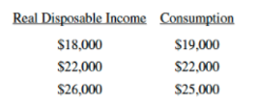
- According to the table above, the MPC =
- 1.33
- 0.9
- 0.8
- 0.75
- Decreasing as real disposable income increases
- Include correctly labeled diagrams, if useful or required, in explaining your answers. A correctly labeled diagram must have all axes and curves clearly labeled and must show directional changes. If the question prompts you to "Calculate," you must show how you arrived at your final answer.

Canada is an open economy that is currently in a recessionary output gap.
(a) Draw a correctly labeled graph of the long-run aggregate supply, short-run aggregate supply, and aggregate demand curves, and show each of the following.
(i) The current equilibrium real output and price level, labeled as Y1Y1 and PL1PL1, respectively
(ii) Full-employment output, labeled YfYf
(b) The central bank and the government do not take any policy actions to close the output gap.
(i) Explain how the economy will adjust to full employment in the long run.
(ii) On your graph in part (a), show how the economy adjusts to full employment in the long run.
(c) Suppose the Canadian government is unwilling to wait for the long-run adjustment process. The marginal propensity to consume is 0.8. The equilibrium real output is $500 billion and the full-employment output is $540 billion.
(i) Calculate the minimum change and indicate the direction of change in government spending required to shift the aggregate demand curve by the amount of the output gap.
(ii) Calculate the minimum change and indicate the direction of change in taxes required to shift the aggregate demand curve by the amount of the output gap.
(d) Assume instead that the Canadian central bank takes actions to restore the economy to full-employment output by influencing investment spending. Draw a correctly labeled graph of the money market, and show the effect of the actions taken by the central bank on the equilibrium interest rate.
(e) Canada and Mexico are trading partners. Draw a correctly labeled graph of the foreign exchange market of the Canadian dollar, and show the effect of the change in the interest rate in part (d) on the value of the Canadian dollar with respect to the Mexican peso.
- A rightward shift in the short-run aggregate supply curve will occur when
- exports exceed imports
- the money supply increases
- the prices of imported raw materials increase
- the stock of physical capital increases
- unions have negotiated a wage increase for their members
- Which of the following will cause an increase in aggregate demand?
- An increase in the price level
- A decrease in income taxes
- An increase in the demand for money
- A decrease in the supply of money
- A decrease in government transfer payments
- A change in which of the following will cause the short-run aggregate supply curve to shift?
I. The price level
II. Government spending
III. The cost of all inputs
- I only
- II only
- III only
- I and II only
- I, II and III
- Automatic stabilizers can do which of the following?
- Offset the destabilizing influence of changes in tax revenues
- Aid the economy to move away from the full-employment output level
- Allow policymakers to formulate a set of rules flexible and comprehensive enough to eliminate discretionary actions
- Cause tax revenues to decrease when gross domestic product (GDP) decreases and to increase when GDP increases
- Allow policymakers to prescribe public works programs during inflationary periods because expenditures for unemployment and welfare have correspondingly decreased
- ﻿A major advantage of automatic stabilizers in fiscal policy is that they
- reduce the public debt
- increase the possibility of a balanced budget
- stabilize the unemployment rate
- go into effect without passage of new legislation
- automatically reduce the inflation rate
- Which of the following will most likely occur if a government adopts an annually balanced budget rule that requires the government to eliminate any deficits or surpluses?
- Unemployment will be eliminated and prices will be stable.
- The national debt will increase.
- Business cycles will become more stable.
- The automatic stabilizing effect of fiscal policy will be eliminated.
- The government will be forced to spend less when there are surpluses.
- Which of the following statements best describes the concept of an automatic stabilizer?
- It is nondiscretionary fiscal policy that mitigates business cycles by increasing aggregate demand during recessions and decreasing aggregate demand during expansions.
- It is discretionary fiscal policy that increases government spending during recessions and decreases government spending during expansions.
- It is a measure of the effect that a change in government spending and investment has on the gross domestic product
- It is a description of how total income is always equal to total expenditures as a measure of gross domestic product
- It is the process whereby surpluses lead to falling prices and shortages lead to rising prices to stabilize market equilibrium
- Which of the following is an example of an automatic stabilizer?
- Discretionary fiscal policy
- Progressive income taxes
- Autonomous consumption
- The spending multiplier
- Cyclical unemployment﻿
- In answering the question, you should emphasize the line of reasoning that generated your results; it is not enough to list the results of your analysis. Include correctly labeled diagrams, if useful or required, in explaining your answers. A correctly labeled diagram must have all axes and curves clearly labeled and must show directional changes.
Assume that the economy of Meekland is in a long-run equilibrium with a balanced government budget.
a. Using a correctly labeled graph of aggregate supply and aggregate demand, show each of the following.
i. Long-run aggregate supply
ii. The output level, labeled YE, and the price level, labeled PLE
b. Assume consumer confidence falls. Show on your graph in part (a) the short-run impact of the change in consumer confidence and label the new equilibrium price level and output Y1 and PL1, respectively.
c. Using a correctly labeled graph of the short-run and long-run Phillips curves, show the effect of the fall in consumer confidence on inflation. Label the initial long-run equilibrium point A and the new short-run equilibrium point B.
d. If the government and the central bank do not pursue any discretionary policy change, how does the fall in consumer confidence affect government transfer payments in Meekland? Explain.
e. Draw a correctly labeled graph of the loanable funds market in Meekland and show the effect of the change in government transfer payments you identified in part (d) on the real interest rate.
f. In the absence of any changes in fiscal and monetary policies, in the long run will the short-run aggregate supply curve shift to the left, shift to the right, or remain unchanged as a result of the fall in consumer confidence? Explain.
- Recessions will most likely be less severe if tax revenues and transfer payments automatically change in which of the following ways?
- Tax revenues increase, and transfer payments increase.
- Tax revenues decrease, and transfer payments decrease.
- Tax revenues increase, and transfer payments decrease.
- Tax revenues decrease, and transfer payments increase.
- Tax revenues do not change, and transfer payments decrease.

1 | E | 6 | A | 11 |  | 16 |  | 21 | D | 26 | B | 31 | D | 36 | C | 41 | B
2 | D | 7 | E | 12 | E | 17 | E | 22 | D | 27 | B | 32 | D | 37 | D | 42
3 |  | 8 | C | 13 | E | 18 | B | 23 | B | 28 | D | 33 |  | 38 | D | 43 | D
4 | D | 9 | E | 14 | A | 19 | C | 24 | E | 29 | D | 34 | D | 39 | D | 44
5 | D | 10 | E | 15 | A | 20 |  | 25 | D | 30 | C | 35 | B | 40 | A | 45

